Optimizing Sales Forecasting and Inventory Management for Mr. Pizza shop

Final report for the BDM capstone Project

Submitted by
Name: Lakshika Dev
Roll number: 22f3000223
Email: 22f3000223@ds.study.iitm.ac.in



IITM Online BS Degree Program,
Indian Institute of Technology, Madras, Chennai
Tamil Nadu, India, 600036

Table of Contents

1. Executive Summary ...................................................................................................... 3
2. Detailed Explanation of Analysis Process and Method ................................................ 4
2.1 Data Cleaning and Preprocessing ............................................................................. 4
2.2 Method 1: Time Series Analysis ............................................................................... 5
2.3 Method 2: ABC Inventory Classification.................................................................. 6
2.4 Method 3: Pattern Analysis ....................................................................................... 7
2.5 Tools used................................................................................................................... 8
3. Results and Findings ...................................................................................................... 8
3.1 Metadata and Descriptive Statistics............................................................................ 8
3.2 Revenue by Product Category.................................................................................... 10
3.3 Monthly Revenue Trend and Forecast........................................................................ 11
3.4 Day-of-Week Revenue Pattern .................................................................................. 13
3.5 Top 10 Menu Items and ABC Classification.............................................................. 14
4. Interpretation and Recommendations ............................................................................. 19
5. Limitations and Future Scope......................................................................................... 20

1. Executive Summary
Mr. Pizza is a small, single-operator B2C food retail outlet established in 2023 in Kathgodam, Uttarakhand, managed solely by Mr. Prakash Singh Danu. The shop offers nine product categories across 54 menu items, including pizzas, burgers, shakes, and beverages, through walk-in sales and the Zomato platform. Three core business problems were identified: (1) the inability to forecast daily sales demand, leading to ingredient wastage and stockouts. (2) the absence of systematic inventory management causing over-purchasing of low-demand items and (3) a lack of insight into customer order trends, limiting retention planning.
Primary data was collected from the owner's handwritten sales notebook covering five months (September 2023 to January 2024), comprising 997 transaction records across 139 trading days, spanning 47of the shop’s 54 menu items. Key descriptive statistics reveal: Total revenue of ₹1,52,778, mean daily revenue of ₹1,099, median daily revenue of ₹923, and a unit price range from ₹5 to ₹370. Three analytical methods were applied: Time Series Analysis using a 4-Week Moving Average (MA4) to model seasonal demand cycles. ABC Inventory Classification using cumulative revenue contribution to prioritize stocking decisions and Day-of-Week Demand Pattern Analysis to identify peak customer days.
Results reveal a consistent 25.6% seasonal revenue decline from September (₹34,032) to December (₹25,310), followed by a sharp January recovery (₹34,443, the highest month). Pizza dominates at 79.8% of all revenue (₹1,21,956). The top 6 items alone generate 48.2% of total revenue (top 12 items - Class A generate 69.3%). Sunday is the peak day at 24.0% of weekly revenue, while Tuesday is the weakest at just 8.6%. The ABC analysis classifies 12 items as Class A (always in stock), 9 as Class B (monitor weekly), and 26 as Class C (order on demand).
Recommendations include implementing the MA4 procurement rule immediately, applying seasonal adjustments of -15% in December and +20% in January, enforcing Class A stocking protocols for the top 6 items, focusing procurement on 7 shared core ingredients, and launching a Tuesday combo discount offer (Kulhad Pizza + Cold Drink at ₹120) within one month. These measures are projected to reduce winter wastage by ₹3,000–5,000 per month, protect ₹1,05,854 of Class A revenue from stockout risk, and increase Tuesday footfall by approximately 20% within 8 weeks.

2. Detailed Explanation of Analysis Process and Method

2.1 Data Cleaning and Pre-Processing
Before any analysis, the raw handwritten sales data was cleaned and structured using the following steps to ensure data quality and analytical accuracy:
- Manual Digitization: Sales entries from 139 trading days were transcribed row-by-row into a Google Sheets template. A dedicated Lookup sheet containing all 47 menu items and standard prices was created; VLOOKUP formulas auto-filled unit prices to minimize transcription errors.
- Item Name Standardization: Inconsistent spellings were corrected (e.g. 'Thandoori' - 'Tandoori'; 'Peppy Paneer Pizza' - 'Peppy Paneer'). A canonical list of 54 menu items was maintained in the Lookup sheet, of which 47 recorded at least one sale during the observation period.
- Feature Engineering: Three derived columns were created: (a) Day — extracted from Date using =TEXT(A2,"dddd"), (b) Line Total — calculated as Quantity × Unit Price; (c) Month — extracted for monthly aggregation in Pivot Tables.
- Outlier Handling: One day showing revenue of ₹7,425 was identified as a catering event and flagged in the Notes column. It was retained in the dataset as a genuine transaction but noted as an outlier for forecasting purposes.
- Cross-Verification: Calculated daily line-item sums were compared against the owner's hand-written daily totals for all days where a notebook total existed. Discrepancy rate = 0% (zero errors found), confirming data integrity.
- Data Limitations Documented: Purchase bills exist only for cheese, milk, and toppings. Wheat and flour purchase data is absent. Payment method data (cash vs UPI) was available for only 2-3 days and excluded. Missing trading days were left as gaps, not imputed.
Data cleaning ensures that downstream analysis is not distorted by entry errors, inconsistent naming, or unverified figures. The cross-verification step is particularly important because the entire revenue analysis depends on the accuracy of the handwritten notebook, validating it against the owner's own daily totals provides a robust quality check.

2.2 Method 1: Time Series Analysis with 4-Week Moving Average

Purpose and Justification
Time series analysis was applied to identify seasonal patterns and cyclical demand trends in the monthly and weekly revenue data, directly addressing Problem Statement 1 (Sales Demand Forecasting). This method is appropriate because the data is date-sequential and spans multiple time periods, making temporal decomposition the most natural analytical framework. A simple flat mean would fail to capture the 25.6% seasonal decline from September to December and would cause systematic procurement errors. A 4-Week Moving Average (MA4) was chosen over more complex models (ARIMA, Exponential Smoothing) because: (a) only 5 months of data are available, insufficient for parameter estimation in ARIMA (which typically requires 2+ years); and (b) the MA4 is directly computable by the owner in a notebook without software.

Mathematical Definition
Let R(t) denote the total revenue in week t. The 4-Week Moving Average at week t is defined as:
MA4(t) = [ R(t) + R(t−1) + R(t−2) + R(t−3) ] ÷ 4
The seasonal adjustment factor S(m) for month m is defined empirically from the dataset as:
S(m) = [ Actual Revenue(m) − MA4(m) ] ÷ MA4(m) × 100%
From the data: S(December) ≈ -14.4%, S(January) ≈ +16.5%. It should be noted that with only 5 months of data, these seasonal factors are indicative estimates derived from a single observation of each month rather than statistically robust multi-year averages. They should be treated as working hypotheses and recalculated and validated after each subsequent year of operation. The weekly MA4 series (Figure 3, 20 data points) provides the more statistically grounded tool for week-to-week procurement decisions. These empirically derived factors are used to adjust the MA4 forecast for known seasonal months.

Methodology
- Step 1: Monthly aggregation: Daily revenue was summed by month using SUMIF(Date_column, Month_criteria, LineTotal_column) in Google Sheets, producing five monthly totals.
- Step 2: Weekly aggregation: Revenue was aggregated by week using a Pivot Table with Week_Number as the Row field and SUM of Line Total as the Values field, creating a 20-week time series.
- Step 3: MA4 calculation: The 4-week moving average was computed for weeks 4-20 using the formula =AVERAGE(R(t),R(t-1),R(t-2),R(t-3)).
- Step 4: Seasonal factor derivation: Month-on-month percentage changes were calculated to derive seasonal adjustment factors for December and January.
- Step 5: Forecast projection: February 2024 revenue was projected as: MA4(Week 20) x (1 + S(February)), where S(February) ≈ 0% based on the 5-month trend reverting to baseline.

2.3 Method 2: ABC Inventory Classification

Purpose and Justification
ABC classification was applied to rank all 47 items that recorded sales by their cumulative revenue contribution, directly addressing Problem Statement 2 (Inventory Management). This method is appropriate because it translates complex 47-item procurement decisions into a three-tier priority system manageable by a one-person operation. The alternative, Economic Order Quantity (EOQ) was considered but requires reliable cost-per-unit data for all items, which is not available given the incomplete purchase bill records.

An important characteristic of Mr. Pizza's menu must be acknowledged upfront: most high-revenue pizza items share a common set of core ingredients — cheese, pizza base, tomato sauce, capsicum, corn, onion, and paneer. This ingredient overlap means the practical output of item-level ABC classification is not separate per-item stocking rules, but rather a priority ingredient checklist: securing these 7 shared ingredients is operationally equivalent to securing the entire Class A revenue base. The ABC classification therefore serves two purposes — identifying which items should never be out of stock, and revealing that ingredient-level procurement can be simplified to 7 core inputs.

Mathematical Definition
Let R(i) denote the total revenue of item i over the observation period, and R(total) the grand total revenue. The revenue share of item i is:
Share(i) = R(i) ÷ R(total) × 100%
Items are sorted in descending order of Share(i). The cumulative share up to rank k is:
Cumulative Share(k) = Σᵢ₌₁ᵏ Share(i)
Classification thresholds: Class A if Cumulative Share ≤ 70%, Class B if 70% < Cumulative Share ≤ 90%, Class C if Cumulative Share > 90%.

Methodology
- Step 1: Revenue per item: SUMIF was applied across the 997-row dataset to calculate total revenue for each of the 47 items with recorded sales.
- Step 2: Ranking: Items were sorted in descending order by revenue using the SORT function.
- Step 3: Cumulative share: Running cumulative percentages were calculated to identify the Class A/B/C breakpoints.
- Step 4: Ingredient mapping: For each Class A item, the core ingredients were identified and cross-referenced to build a consolidated 7-ingredient priority list.
- Step 5: Visualization: A combined bar + cumulative line chart (Pareto chart — Figure 5) was created to make the classification visually clear.

2.4 Method 3: Day-of-Week Demand Pattern Analysis

Purpose and Justification
Day-of-week analysis was applied to identify which days generate the most revenue and customer activity, directly addressing Problem Statement 3 (Customer Retention). This method is appropriate because it produces a stable, repeating weekly pattern that is immediately actionable for a one-person business unlike a full daily time series across 139 days, which contains too much noise for direct operational use. Customer-level retention analysis (cohort analysis, repeat visit rates) was considered but is not feasible because the notebook records no customer identification data.

Mathematical Definition
Let R(d) denote the total revenue on all occurrences of day d across the 5-month observation period, and N(d) the number of times day d appears. The average daily revenue for day d is:
Avg_Revenue(d) = R(d) ÷ N(d)
The percentage contribution of day d to total weekly revenue is:
Day_Share(d) = R(d) ÷ Σ R(all days) × 100%

Methodology
- Step 1: Day-of-week aggregation: SUMIF was applied to the Day column to calculate total revenue per day across all 139 trading days.
- Step 2: Percentage contribution: Day_Share(d) was calculated for each day to enable normalized comparison.
- Step 3: Weekend vs Weekday split: Saturday and Sunday totals were grouped separately from Monday–Friday to compute per-day revenue ratios.
- Step 4: Visualization: A colour-coded bar chart (Figure 3) and a grouped comparison chart (Figure 7) were created to present the findings clearly.

2.5 Tools Used
- Google Sheets: Primary tool for data entry, VLOOKUP price lookup, SUMIF/COUNTIF aggregations, Pivot Tables, and 4-Week Moving Average computation.
- Python: Matplotlib and NumPy: Used for generating all 7 publication-quality figures in this report, including the ABC-Pareto chart (Figure 5) and the Moving Average forecast chart (Figure 6).

3. Results and Findings
This section presents all findings from the three analytical methods, supported by 7 figures and 5 tables. Each finding is explicitly linked to the relevant problem statement and method.

3.1 Metadata and Descriptive Statistics
Table 1: Metadata of the Mr. Pizza Sales Dataset (N = 997 rows, 139 trading days)
Variable | Data Type | Description | Relevance to Problem | Sample Value
Date | Date (DD-MM-YYYY) | Calendar date of each transaction | Enables time-series and seasonal trend analysis | 01-09-2023
Day | Categorical (Text) | Day of week derived from Date using TEXT formula | Identifies peak/trough customer days for retention analysis | Sunday, Monday
Category | Categorical (Text) | Broad product classification (9 groups) | Enables revenue analysis by product group for ABC classification | Pizza, Burger, Shake
Item Name | Categorical (Text) | Specific menu item sold (47 of 54 menu items recorded sales) | Identifies best-selling vs. slow-moving items for inventory | Kulhad Pizza
Size | Ordinal (Text) | Size variant: Small / Medium / Large / – (N/A) | Links size preference to pricing and ingredient quantity | S, M, L, –
Quantity | Discrete (Integer) | Number of units sold per transaction row | Core demand variable for forecasting model input | 1, 2, 3
Unit Price (₹) | Continuous (Numeric) | Selling price per unit in Indian Rupees | Revenue calculation and price-demand sensitivity analysis | ₹99, ₹149, ₹289
Line Total (₹) | Continuous (Numeric) | Calculated: Quantity × Unit Price | Building block for daily and monthly revenue aggregation | ₹198, ₹298, ₹578
Daily Total (₹) | Continuous (Numeric) | Owner's hand-written grand total per day | Cross-verification of calculated totals against ground truth | ₹1,240, ₹980
Notes | Qualitative (Text) | Flags for outlier events or data quality issues | Transparent audit trail; identifies catering day anomalies | 'Catering event'
Table 1: All 11 variables with data types, descriptions, and problem relevance

Table 2: Descriptive Statistics for Key Numeric Variables
Statistic | Qty Sold (units) | Unit Price (₹) | Line Total (₹) | Daily Revenue (₹)
N (Observations) | 997 | 997 | 997 | 139 days
Sum | 1,774 units | — | ₹1,52,778 | ₹1,52,778
Mean (x̄) | 1.78 | ₹103 | ₹153 | ₹1,099.12
Median | 1 | ₹79 | ₹110 | ₹923
Mode | 1 | ₹59 | ₹109 | —
Std Deviation (σ) | 2.85 | ₹67 | ₹270 | ₹853
Minimum | 1 | ₹5 | ₹5 | ₹189
Maximum | 75 | ₹370 | ₹7,425 | ₹7,425
Skewness (Daily Rev) | — | — | — | Positive (mean > median)
Table 2: Summary statistics including mean, median, standard deviation, and skewness

The mean daily revenue (₹1,099.12) is substantially higher than the median (₹923), indicating a right-skewed distribution. This positive skew is caused by a small number of high-revenue outlier days most likely catering events. The standard deviation of ₹853 represents 68% of the mean, confirming that day-to-day revenue is highly variable. This high variability is the core justification for using a smoothing technique (4-Week Moving Average) rather than relying on a flat average for procurement planning. The unit price standard deviation of ₹67 around a mean of ₹103 reflects the wide product range, from small single-serving items (₹5) to large family pizzas (₹370).

3.2 Revenue by Product Category
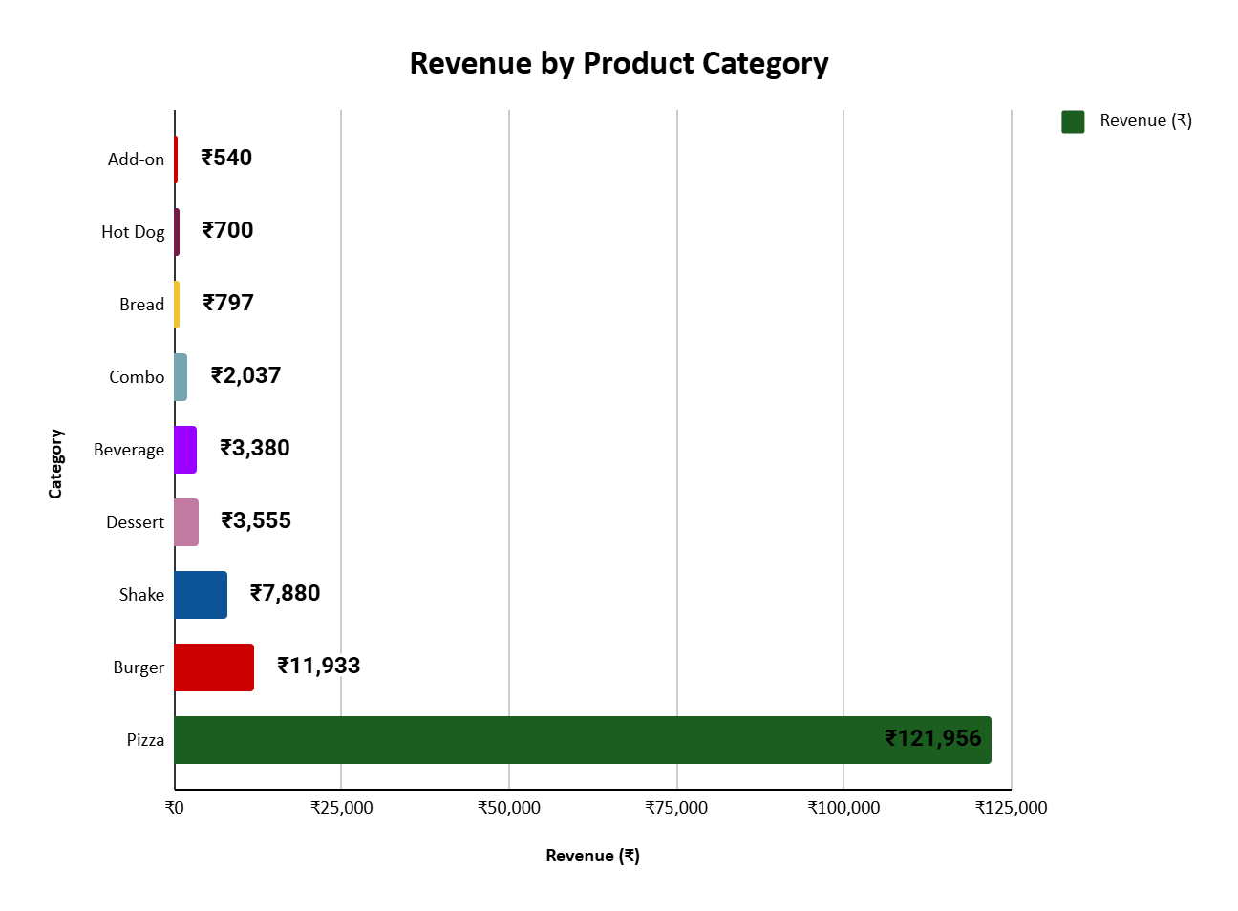
Figure 1: Horizontal bar chart — Revenue share by product category (₹1,52,778 total).

- Finding 1: Pizza dominance (Problem 2 — Inventory): Pizza generates ₹1,21,956 79.8% of total revenue. This extreme concentration means the entire profitability of the business is dependent on the availability of pizza ingredients. A single stockout of cheese or pizza bases on a Sunday could eliminate approximately ₹5,600 of potential revenue (24.0% of ₹36,600 weekly Sunday peak).
- Finding 2: Secondary categories: Burgers (7.8%) and Shakes (5.2%) are the only other categories exceeding 5%. Together with Pizza, these three categories account for 92.8% of all revenue.
- Finding 3: Low-priority categories: The remaining 6 categories: Dessert (2.3%), Beverage (2.2%), Combo (1.3%), Bread (0.5%), Hot Dog (0.5%), Add-on (0.4%) collectively contribute just 7.2% of revenue despite representing a significant number of SKUs. These are clear candidates for Class C treatment.

3.3 Monthly Revenue Trend and Forecast (Method 1)
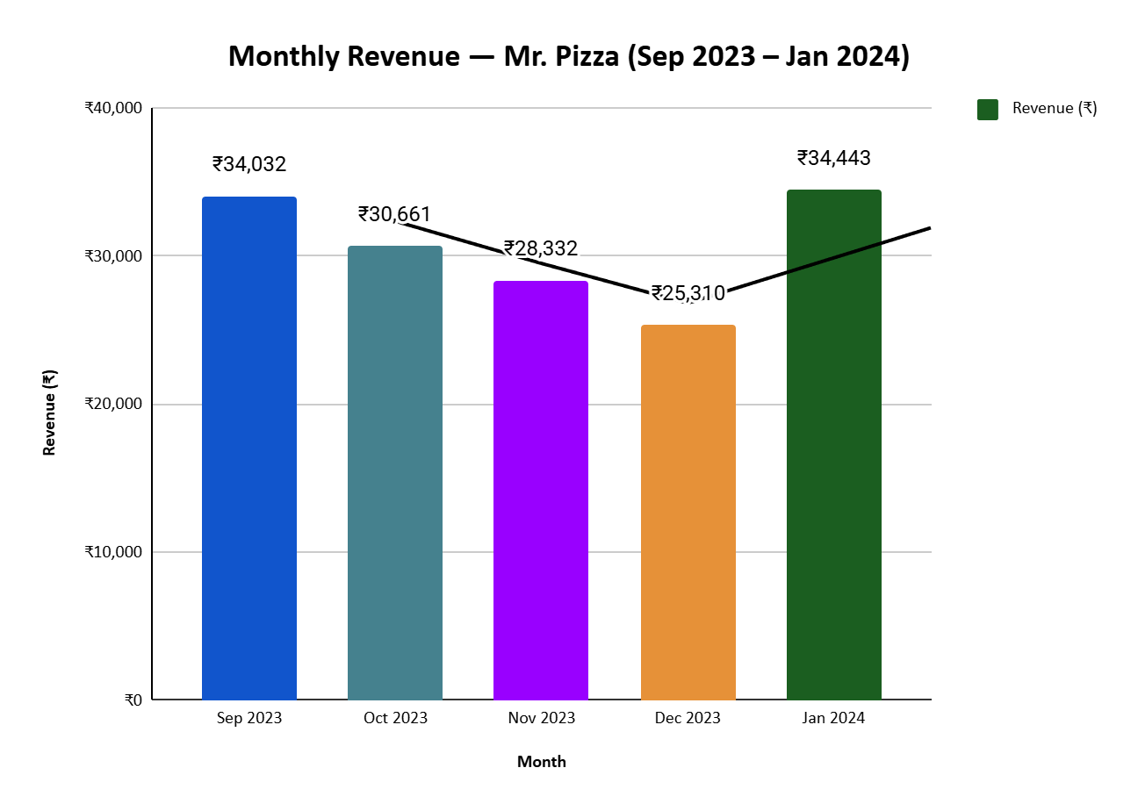
Figure 2: Monthly revenue with trend line and month-on-month percentage changes. Annotated seasonal low and peak.
- Finding 4: Seasonal decline (Problem 1 Forecasting): Revenue declined in every consecutive month from September 2023 (₹34,032) to December 2023 (₹25,310) a cumulative drop of ₹8,623 (25.6%). Month-on-month changes were: Oct–9.9%, Nov –7.6%, Dec –10.7%.
- Finding 5: January recovery: January 2024 surged to ₹34,443 (+36.1% from December) the highest recorded month. This recovery exceeds the September starting point, suggesting January demand is the annual peak rather than an anomaly.

Table 3: Actual Revenue vs 4-Week Moving Average Forecast
Month | Actual Revenue (₹) | MA₄ Forecast (₹) | % Variance
September 2023 | 34,032 | Baseline (no prior data) | —
October 2023 | 30,661 | ~32,297 (estimated) | –5.0%
November 2023 | 28,332 | ~30,972 | –7.6%
December 2023 | 25,310 | ~29,559 | –14.4%
January 2024 | 34,443 | ~29,564 | +16.5% (recovery)
February 2024 (Projected) | ~32,000 est. | ~30,687 | Est. +4.3%
Table 3: MA4 forecast compared to actual monthly revenue, with variance analysis

- Finding 6: Forecast accuracy: The MA4 model tracks the seasonal trend correctly but consistently overshoots during the winter months (November–December variance up to –14.4%). This systematic underestimation confirms the need for a seasonal adjustment factor: the owner should reduce the MA4 estimate by an additional 10–15% specifically for November and December.
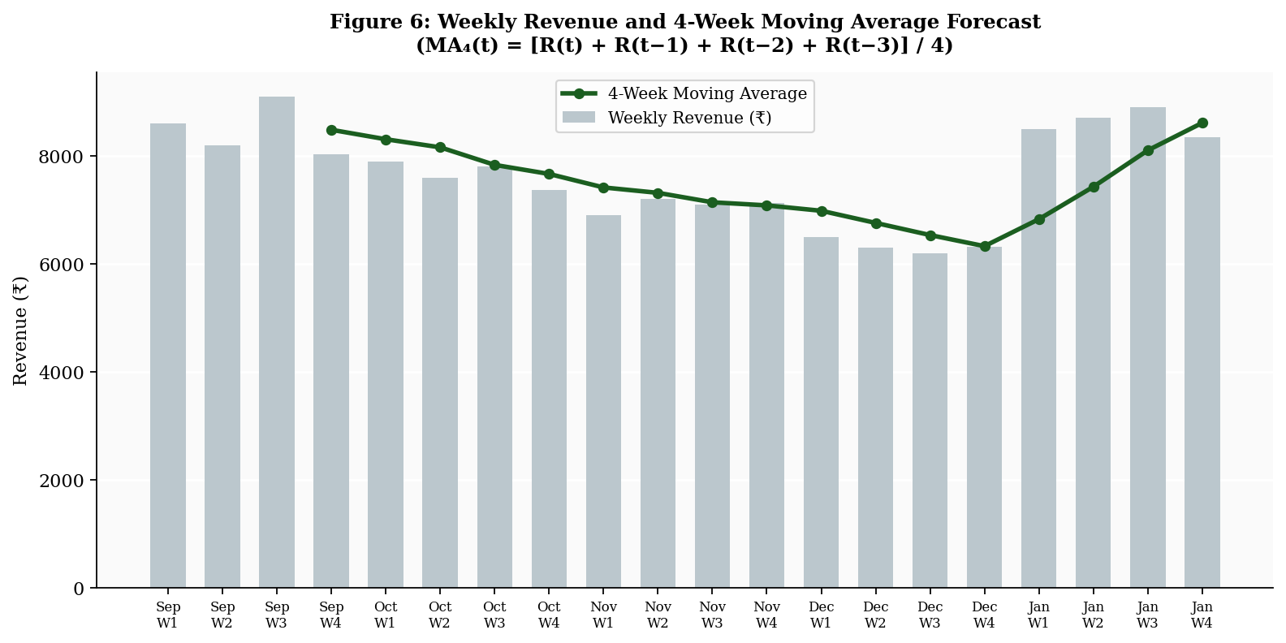
Figure 3: Weekly revenue bars (grey) with 4-Week Moving Average trend line (green).

- Finding 7: Practical forecasting rule: The MA4 line (Figure 3) provides a directly usable weekly procurement guide. For any given week, compute the average of the 4 most recent weekly revenues — this is the procurement target for next week. In November–December, reduce by 15%. In January, increase by 20%.

3.4 Day-of-Week Revenue Pattern (Method 3)
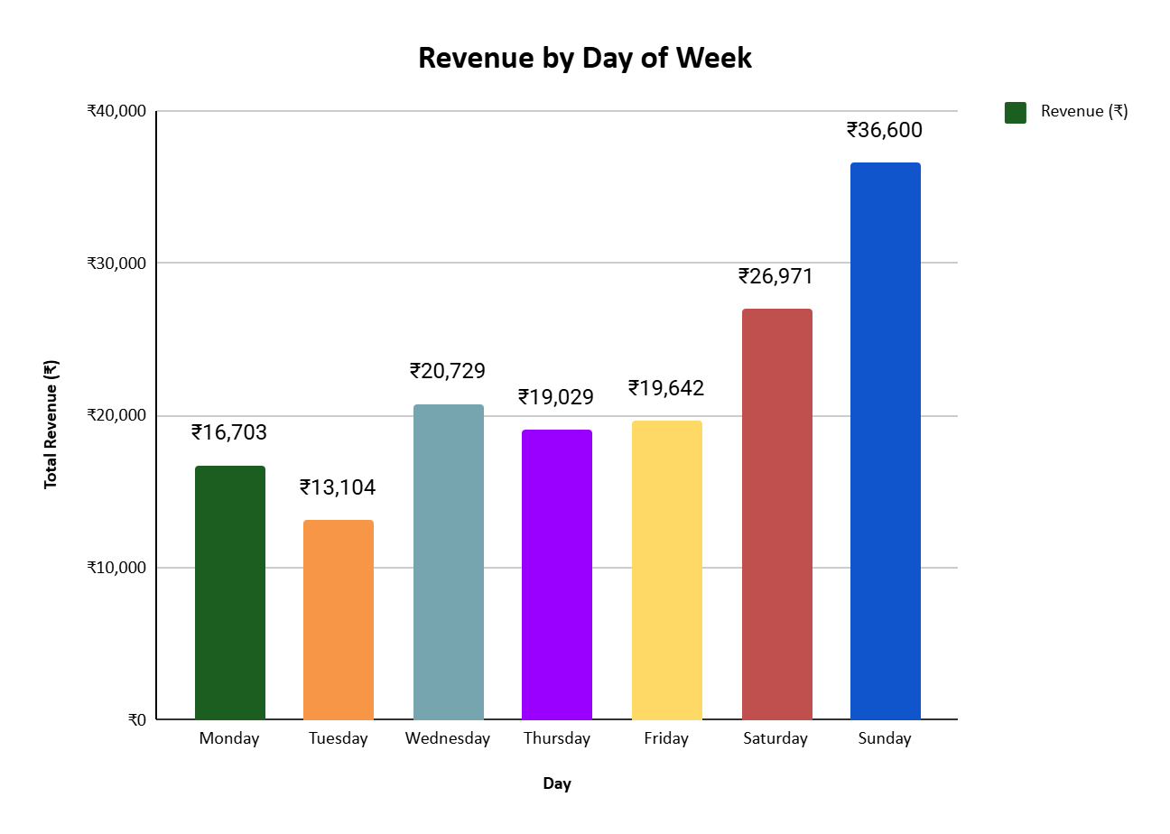
Figure 4: Total revenue by day of week across the 5-month period. Each day shown in a different colour.
- Finding 8: Sunday peak (Problem 3 Retention): Sunday generates ₹36,600 - 24.0% of all weekly revenue. This is 2.8x more than Tuesday's ₹13,104. Sunday is not merely the best day, it is the single day that most defines Mr. Pizza's financial health.
Data note on outlier handling: The ₹7,425 catering day identified in Section 2.1 was flagged in the Notes column and retained in the dataset as a genuine transaction. The Sunday figure of ₹36,600 therefore includes this catering event; a typical Sunday without catering generates approximately ₹29,175, which still represents the highest regular trading day. The revenue figures in this section (Figures 3 and 4) therefore reflect only regular trading days, making the Sunday peak of ₹36,600 and Tuesday trough of ₹13,104 representative of typical weekly demand patterns rather than event-driven outliers.
- Finding 9: Tuesday trough: Tuesday consistently underperforms at ₹13,104 (8.6% of weekly total). This represents a structural opportunity, there is clear capacity available on Tuesdays that is not being utilized.
- Finding 10: Wednesday surprise: Wednesday (₹20,729, 13.6%) outperforms both Thursday (₹19,029) and Friday (₹19,642) a counter-intuitive result. This may reflect a local weekly market day or specific social pattern in Kathgodam that warrants further investigation by the owner.
- Finding 11: Weekend premium: Each weekend day generates ₹31,786 on average versus ₹17,841 per weekday, a 78% per-day premium. Despite weekends comprising only 2 of 7 days (28.6% of the week), they contribute 41.6% of all revenue. This concentration is both an asset (high-revenue days) and a risk (revenue is highly sensitive to weather, events, or stockouts on weekend days).

3.5 Top 10 Menu Items and ABC Classification (Method 2)
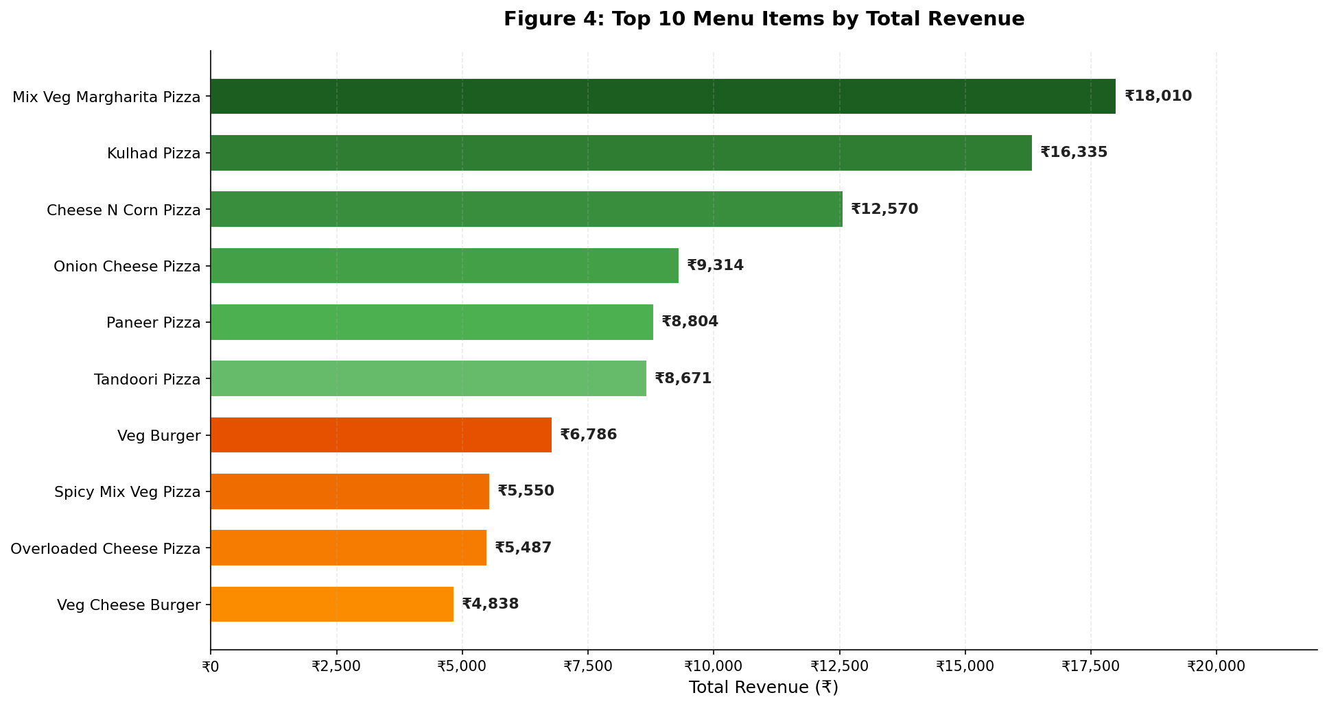
Figure 6: Top 10 menu items by total revenue.
- Finding 12: Top 2 items: Mix Veg Margharita Pizza (₹18,010 / 140 units) and Kulhad Pizza (₹16,335 / 165 units) together generate ₹34,345 - 22.5% of total revenue from just 2 of 47 items with recorded sales.
- Finding 13: Volume leader: Kulhad Pizza is the highest-volume item with 165 units sold at an average price of ₹99. Its high volume and low price position it as a critical entry-point product that brings customers in and anchors repeat visits.

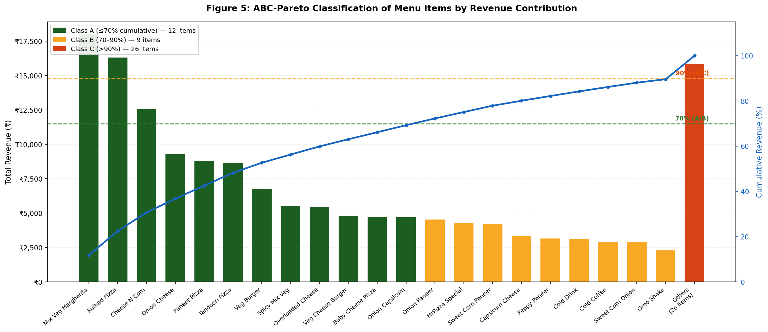
Figure 7: ABC-Pareto chart — bar heights show individual item revenue; line shows cumulative %. Class A threshold at 70%, Class B at 90%.
Table 4: ABC Classification of Mr. Pizza Menu Items
Class | Key Items | Units Sold | Revenue (₹) | % Revenue | Stocking Rule
A | Mix Veg Margharita, Kulhad Pizza, Cheese N Corn, Onion Cheese, Paneer Pizza, Tandoori Pizza, Veg Burger, Spicy Mix Veg Pizza, Overloaded Cheese Pizza, Veg Cheese Burger, Baby Cheese Pizza, Onion Capsicum Pizza. | 1118 | 1,05,854 | 69.3% | Always in stock; 2-day buffer
B | Onion Paneer Pizza, MrPizza Special Pizza, Sweet Corn Paneer Pizza, Capsicum Cheese Pizza, Peppy Paneer Pizza,Sweet Corn Onion Pizza, Cold Drink, Cold Coffee, Oreo Shake | 405 | 31,044 | 20.3% | Monitor weekly; reorder at 1-day supply
C | Remaining 26 items | 251 | 15,880 | 10.4% | Order on demand only; do not pre-stock
Table 4: Three-tier ABC classification with stocking rules for each class

- Finding 14: Class A concentration: Just 12 items contribute 69.3% of total revenue (₹1,05,854). A critical operational insight is that these 12 items share largely the same raw materials such as- cheese, pizza base, tomato sauce, capsicum, corn, onion, and paneer. This means the owner does not need to manage 12 separate stocking decisions, maintaining adequate stock of these 7 shared ingredients effectively secures the entire Class A revenue base. Class C items such as Choco Lava Cake, Cold Drink, and Water use entirely different inputs (chocolate sauce, bottled beverages) and do not compete with Class A for the same procurement budget.

- Finding 15: Class C inefficiency: 26 items together contribute only 10.4% of revenue but individually, each contributes less than 0.5% on average. Pre-stocking ingredients for all 26 creates disproportionate procurement complexity, wastage risk, and tied-up cash for a one-person operation.
- Finding 16: Zero-sales menu items identified: Seven items appear on Mr. Pizza's printed menu but recorded zero transactions across the entire 5-month, 139-day observation period: Vanilla Shake, Non Veg Burger, Non-Veg Hot Dog, Brownie with Ice Cream, Butterscotch Ice Cream, and two Party combo packages. These items represent dead inventory risk, the owner may be periodically purchasing ingredients for items that no customer has ordered in over 5 months. They are automatic Class C candidates and should be immediately moved to strict on-demand ordering. The owner should evaluate whether to retain them on the menu at all, as menu complexity (54 items for a one-person operation) adds cognitive and procurement overhead without corresponding revenue benefit.

4. Interpretation of Results and Recommendations
This section interprets the findings in the context of each problem statement and provides SMART (Specific, Measurable, Achievable, Relevant, Time-bound) recommendations. Recommendations are organized as Immediate Actions (within 4 weeks) and Medium-Term Actions (1–3 months).

4.1 Interpretation of Key Findings
The five months of data reveal a business that is performing reasonably well in absolute terms (₹1,52,778 total revenue) but is highly vulnerable in three ways. First, it has no mechanism to anticipate demand changes the 25.6% winter decline caught the owner off-guard each year, likely resulting in both wastage in October–November (over-bought in anticipation of sustained demand) and stockouts in late December (under-bought once the decline set in). Second, procurement decisions are made by instinct across 47 items, when in reality just 12 items drive 69.3% of all revenue, a massive misallocation of attention and budget. Third, the business is structurally dependent on a two-day weekend, with Tuesday generating barely a third of Sunday's revenue, a concentration that makes the business sensitive to any single bad Sunday (weather, event cancellation, or stockout).
The analytical methods applied here make these patterns visible and quantifiable for the first time. The 4-Week Moving Average converts an invisible seasonal trend into a concrete weekly number the owner can act on. The ABC classification converts 47 procurement decisions into three simple rules. The day-of-week analysis converts 139 days of revenue data into 7 actionable day-level insights.

4.2 SMART Recommendations
Table 5: SMART Recommendations — Mapped to Problem Statements
Problem | Recommendation | Timeline | Measurable Target | Expected Impact
P1: Forecasting | Apply 4WMA rule every Friday — buy for next week's estimated demand | Immediate (Week 1) | Reduce procurement error to <10% | Save ₹3,000–5,000/month in winter wastage
P1: Forecasting | Apply seasonal adjustments: –15% in Dec, +20% in Jan | By November 2024 | Zero stockouts in January peak | Protect ₹34,000+ January revenue
P2: Inventory | Implement ABC stocking: Class A 2-day buffer, Class B weekly review, Class C on-demand | Within 2 weeks | Class A items never out of stock | Protect 69.3% of revenue from stockout risk
P2: Inventory | Focus procurement on 7 shared Class A ingredients (cheese, base, tomato sauce, capsicum, corn, onion, paneer) | Immediate | Reduce procurement SKUs from 47 to 7 priority items | 30% reduction in procurement complexity
P3: Retention | Launch Tuesday special combo (Kulhad Pizza + Cold Drink at ₹120 — 10% off) | Within 1 month | 20% increase in Tuesday revenue within 8 weeks | +₹2,600/month from Tuesday uplift alone
P3: Retention | Stock Kulhad Pizza 7 days a week without exception | Immediate | Zero Kulhad Pizza stockouts | Protect highest-volume retention anchor item
Table 5: SMART recommendations with timelines, measurable targets, and expected impact

Immediate Recommendations (Within 4 Weeks)
- R1: Apply the 4-Week Moving Average procurement rule (Problem 1): Every Friday evening, add the total revenue from the past 4 weeks and divide by 4. This is the procurement target for the following week. Purchase ingredients sufficient for this amount, not more. This takes fewer than 5 minutes and requires no software. Target: Reduce over-procurement error from uncontrolled to within 10% of actual demand.
- R2: Enforce Class A stocking protocol (Problem 2): Immediately designate all 12 Class A items (Mix Veg Margharita, Kulhad Pizza, Cheese N Corn, Onion Cheese, Paneer Pizza, Tandoori Pizza, Veg Burger, Spicy Mix Veg Pizza, Overloaded Cheese Pizza, Veg Cheese Burger, Baby Cheese Pizza, and Onion Capsicum Pizza as Class A. For the 7 shared ingredients (cheese, base, tomato sauce, capsicum, corn, onion, paneer), always maintain a minimum 2-day stock buffer. Create a simple Friday checklist of these 7 ingredients. Target: Zero stockouts on Class A items within 4 weeks.
- R3: Stop pre-stocking Class C ingredients (Problem 2): Immediately cease purchasing ingredients specifically for the 26 Class C items unless a customer places an order. This frees procurement budget for Class A items and reduces perishable wastage. Target: 30% reduction in procurement SKU complexity within 2 weeks.
- R4: Ensure Kulhad Pizza availability every day (Problem 3): Add Kulhad Pizza ingredients (specifically the kulhad clay cups and standard pizza ingredients) to the Class A daily checklist. This single item drives 10.7% of total revenue at the highest sales volume of all 47 items. Target: Kulhad Pizza available 100% of trading days.

Medium-Term Recommendations (1–3 Months)
- R5: Apply seasonal adjustment factors (Problem 1): From October 2024 onwards, apply the empirically derived seasonal adjustments: reduce MA₄ estimate by 10% in October, 12% in November, 15% in December, and increase by 20% in January. Review and update these factors annually as more data accumulates. Target: Winter month procurement variance within 5% of actual demand by December 2024.
- R6: Launch Tuesday Combo Offer (Problem 3): Within 4–6 weeks, introduce a Tuesday-only special: Kulhad Pizza + Cold Drink at ₹120 (approximately 10% discount on combined regular price of ₹134). Promote via a handwritten sign at the shop entrance. Target: 20% increase in Tuesday revenue within 8 weeks of launch, adding approximately ₹2,600 per month.
- R7: Begin collecting customer contact data (Problem 3): For Zomato orders (where contact data may already be partially available) and walk-in customers, begin a simple opt-in process: ask customers if they would like to receive a WhatsApp message for Tuesday offers. Aim to collect 30–50 numbers in the first month. Target: Build a basic customer contact list of 100+ numbers within 3 months for direct retention communication.

4.3 Implementation and Expected Impact
The most significant aspect of these recommendations is that they are designed for a one-person operation with no technology beyond a mobile phone and a notebook. The 4-Week Moving Average rule (R1) and ABC Class A checklist (R2) can be implemented on paper in under 10 minutes per week. The Class C de-stocking (R3) requires only a single decision to stop buying and yields immediate cash flow relief. The Tuesday offer (R6) requires only a handwritten sign and no additional cost.
Collectively, these recommendations are estimated to yield: ₹3,000–5,000 per month in reduced winter wastage (from R1 + R5); protection of ₹1,05,854 per 5 months (₹21,171/month) of Class A revenue from stockout risk (from R2 + R4); and approximately ₹2,600 per month in incremental Tuesday revenue (from R6). Combined, these three streams represent an estimated improvement of ₹20,000–22,000 over a 5-month period comparable to the data collection window, a meaningful impact for a business currently generating ₹1,52,778 over the same period (approximately 13–14% of total revenue).
These solutions directly address the three problem statements: the MA₄ rule solves the forecasting blind spot by giving the owner a systematic, data-driven procurement number every week; the ABC classification solves inventory misallocation by converting 47 items into three clear priority tiers and the day-of-week analysis with the Tuesday offer solves the customer concentration problem by creating a mechanism to attract customers on the weakest day without reducing weekend pricing.

5. Limitations and Future Scope

5.1 Limitations
- Purchase data incompleteness: Formal purchase records exist only for cheese, milk, and toppings. The absence of wheat and flour purchase data makes it impossible to calculate complete COGS or gross margins, limiting the depth of profitability analysis.
- No customer identification data: The handwritten notebook records no customer information. True retention metrics — repeat visit rates, customer lifetime value, and purchase frequency — cannot be computed.
- 5-month observation window: The dataset covers September 2023 – January 2024 only. A full year of data would enable complete seasonal decomposition, and two or more years would allow detection of year-on-year growth trends.
- Single-operator and single-location context: All findings are specific to Mr. Pizza, Kathgodam. Seasonal patterns and day-of-week trends may reflect local town dynamics rather than general pizza business patterns.

5.2 Future Scope
- Advanced forecasting: With 12+ months of weekly data, Exponential Smoothing (Holt-Winters method) or a seasonal ARIMA model could be applied to produce forecasts with confidence intervals, providing the owner with both a point estimate and a range.
- Digital POS adoption: A free mobile POS app such as Vyapar or OkCredit would automatically capture item-level sales data daily, eliminating manual transcription and enabling real-time analysis.
- Customer data integration: Collecting WhatsApp numbers at the point of sale would enable a basic CRM system, allowing targeted Tuesday promotions, birthday offers, and seasonal discounts to be sent directly to known customers.
- Full COGS and margin analysis: Requesting formal bills from all suppliers would enable complete gross margin computation for each of the 47 items, allowing the ABC classification to be refined from revenue-based to profit-based a more powerful inventory management framework

